NPVR Components
Installation and Operation Guide

Draft Notice
The information in this draft is SeaChange Confidential and is the property of:
SeaChange International Inc.
ZQ Interactive (Shanghai) Ltd.
Confidential material must not be disclosed to any party without prior written consent from SeaChange International Inc.
The information in this draft is not a commitment by SeaChange International Inc. and ZQ Interactive (Shanghai) Ltd. to particular features or capabilities of the product or to the publication or content of its documentation. ZQ Interactive retains the right to postpone, revise, or cancel any proposed product and documentation at any time prior to the release of the product or the publishing of the documentation.

SeaChange International Inc.
ZQ Interactive (Shangai).Ltd.
Contents
1 Introduction 4
1.1 Purpose 4
1.2 Textual Usage 4
2 Environment 5
3 System overview 6
3.1 System Architecture 6
3.2 Component description 6
3.2.1 PM 6
3.2.2 IM 7
3.2.3 Uploader 7
3.2.4 Notice 8
4 Install AssetGear 9
4.1 Overview 9
4.2 Install 9
4.3 Registry Setting 10
4.4 Start the service 12
5 Install EventCollector 14
5.1 Overview 14
5.2 Install 14
5.3 Configuration 15
5.3.1 Registry setting 15
5.3.2 External Configuration File 15
5.3.3 Sample External Configuration File 16
6 Recommend registry setting for NPVR 19
6.1 IsaContent Configuration 19
6.2 IsaRDS Configuration 19
6.3 AssetGear Configuration 20
7 References 21

Revision History
Version | Revise Date | Owner | Notes
1.0 | 2006-2-14 | Mei zhang | Document Combined

Introduction

Purpose
This documents servers as a guideline for installation NPVR components products. The purpose of the document is to introduce the installation steps.

Textual Usage
Font
Italic font is used for emphasis, document titles, and technical terms.
UPPERCASE items are acronyms.

Environment
Software Environment:
Dependent program:
CORBA Naming Service and CORBA Notification Service.
ACE-TAO will be described here as a sample.
Activeperl must be installed that can run the isasetup.pl file.
Java Runtime Environmnet kit “JRE” must be installed on the machine which EventCollector service want to install. The directory which jvm.dll is existed, add it to the system path (it usually exists in %JavaHome%\bin\client).
Add Entries into Host file
Add following entries into the host file(%Windir%\system32\drivers\etc\hosts)
on the machine which AssetGear service are hosted.
- nn.nn.nn.nn SeaChangeContentStore
where nn.nn.nn.nn is the local IP of IsaContent.
- nn.nn.nn.nn NameServer
where nn.nn.nn.nn is the IP Address of the machine on which naming service.
Make sure there is an administrator account “SeaChange” with password “SeaChange” on the machine, the account must allow the service to run as it.

System overview

System Architecture
The NPVR subsystem consists of the following hardware components:
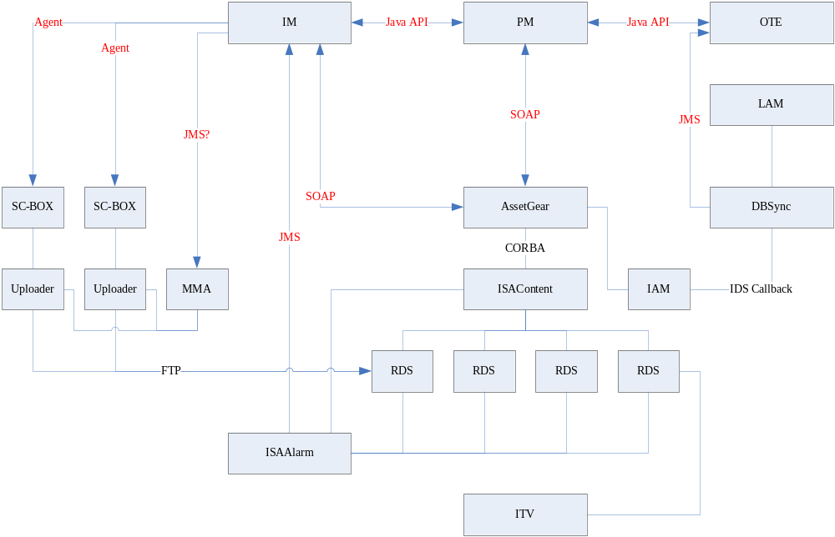
Figure 1 System Architecture

Component description

PM
Maintain the program information; maintain the schedule for program (channel, start time and end time, channel information in PM is import from IM). It also sends capture request to IM base on program setting or request from OTE.
Control some behavior at system level, channel level and program level, like generate trick file for program or not, QC windows duration.
Program has priority, it is base on request count (how many user requests the program, it come from OTE request). Higher priority capture and upload will start first.

IM
Maintain capture and upload task, and communicate with SC-BOX, MMA and AssetGear to execute the capture and upload.
IM will extend interface with SC-BOX, can capture and upload at same time, or capture to file and upload later.
When IM execute upload task, it knows how many RDS it can use (base on configuration) and how many RDS it used now (base on current running tasks). These RDS resource will be used by IM exclusively.
When IM upload a file, it should know the node which the file belong to, and should ask Uploader on that node to upload the file.
When IM upload file, it check RDS resource first, if RDS available, it will assign resource on RDS via AssetGear then check Uploader resource, if Uploader resource available, it will start upload. If Uploader resource is not available, task execution will cancel and retry later, and IM will send request to AssetGear to release resource.
IM also clean uploaded and failed media file.

Uploader
Uploader belongs to SC-BOX. One SC-BOX node has one Uploader on it local machine.
Uploader can control uploading bit rate (Since RDS processing speed is lower that Uploader, if feed speed is too high RDS can not handle it, Uploader should control the upload speed).

Notice
In this document will introduce AssetGear and EventCollector first.
EventCollector is the module equal to “ISAAlarm” service.

Install AssetGear

Overview
ISA components can do PWE(play while encoding) RTE ingest and support up to 15 ingest streams per mediacluster node, So nPVR decide to use ISA component to ingest content. ISA use CORBA for communication, but IM and PM use SOAP for remote communication, AssetGear is a gateway between ISA components and IM & PM components, AssetGear receive the CreateAsset request from IM and then send request to ISA component's to create asset and pushcontent session, then query metadata from PM and update the metadata to itv system.

Install
Find the directory of the installation file: NpvrSetup.pl. In a command console, run:
NpvrSetup.pl --service=AssetGear or
Perl NpvrSetup.pl --service=AssetGear
The following messages will be prompted to complete the setup.
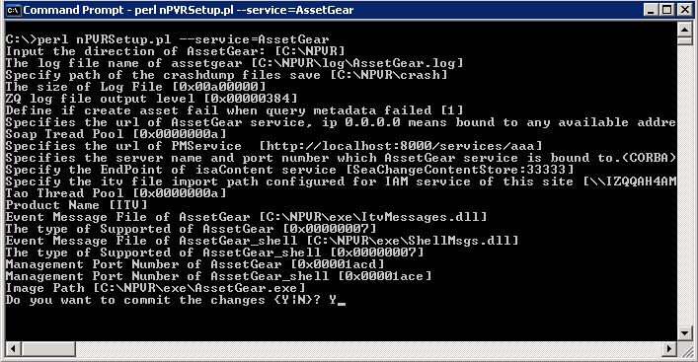
Figure 2 AssetGear Installation Window
This setup automation will show the previous configuration values if they have been setup already, otherwise, the default value prompted will be recommended value by the installation. Those default values will be taken by simple entering empty lines.
If it is a new installation or you make made some change, be sure that type “Y” when the message “Do you want to commit the changes {Y|N}?” appears.
A service restart is required to make the new setting effective whenever the setting has been changed:
Instserv AssetGear restart

Registry Setting
Configuration in IAM
Open “SeaChange AssetManager”, right click on the site name and select “modify” to open “Modify Site” dialog box, lick on the “Import” table:
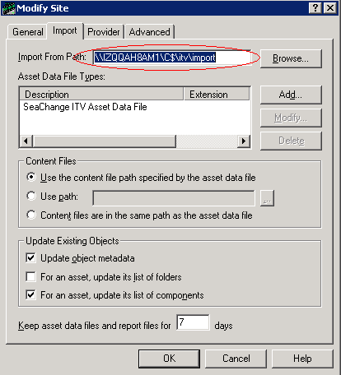
Figure 3 Modify Site
After the setup automation, all the related registry will be added. For registry setting, please refer to “Registries.xls”.
The following register entries need to configuring:
Register Entry | Value Description
ItvImportPath | The same value in “Import From Path” set in Asset Manager. Please refer to Figure 3: Modify Site
AssetGearUrl | Specifies the url of AssetGear service
MetadataGatewayUrl | Specifies the url of PMService
ContentStoreEndPoint | Specifies EndPoint of isaContent Service
ORBEndPoint | Specifies the server name and port number which AssetGear is bound to(CORBA).
UpdateMdFailCreateAssetFail | Default value is “1”,  1 - Create asset fail if query metadata failed.  0 – Ignore the error and create asset success if query metadata failed.

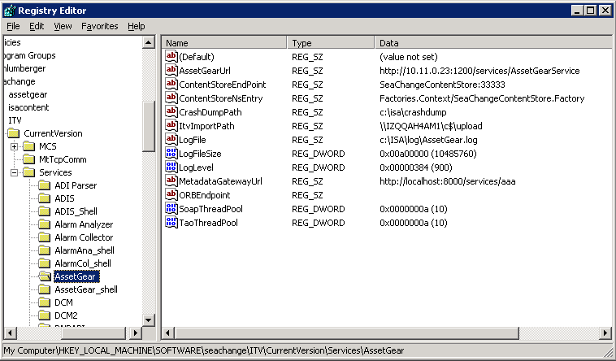
Figure 4 AssetGear Registry Configuration

Start the service
Before start the service verify the registry’s setting of isacontent
“EnableAssetGear” must be 1, it can be checked with “SeaChange Service Management Utility”, connect the machine which installed the isacontent services and open isaContent in order to verify the registry setting.
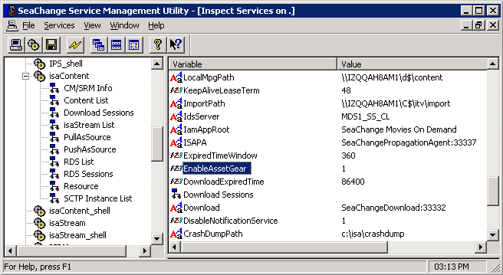
Figure 5 IsaContent registry setting
After verify the registry then start the service as the following command:
instserv assetgear start or
start the service in services
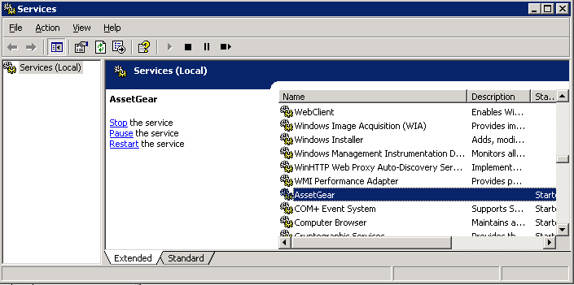
Figure 6 Services

Install EventCollector

Overview
EventCollector is a tool which saves the isa logs and uses JMS send messages to IM.

Install
Note: If Eventcollector is upgrade only, Please first backup the configure file IsaAlarm.ini. Then do the operation as the same of a new install. After installation, restore the configure file IsaAlarm.ini.

Find the directory of the installation file: NpvrSetup.pl. In a command console, run:
NpvrSetup.pl --service=EventCollector or
Perl NpvrSetup.pl --service= EventCollector
The following messages will be prompted to complete the setup.
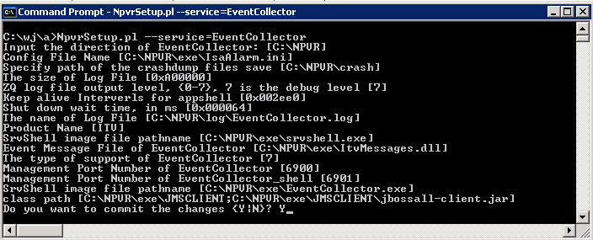
Figure 7 EventCollector Installation window
This setup automation will show the previous configuration values if they have been setup already, otherwise, the default value prompted will be recommended value by the installation. Those default values will be taken by simple entering empty lines.
If it is a new installation or you make made some change, be sure that type “Y” when the message “Do you want to commit the changes {Y|N}?” appears.
A service restart is required to make the new setting effective whenever the setting has been changed:
Instserv EventCollector restart

Configuration

Registry setting
After the setup automation, all the related registry value will be updated. Please refer to NpvrRegistries.xls for more detail.
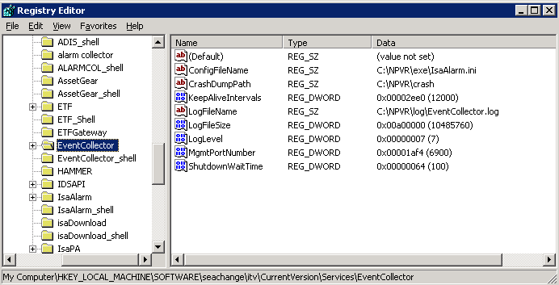
Figure 8 EventCollector Registry Configuration

External Configuration File
EventCollector service loads an external configuration file that is specified in the registry:
[HKLM_LOCAL_MACHINE\SOFTWARE\SeaChange\ITV\CurrentVersion\Services\EventCollector] ConfigFileName
The external configuration file is INI-like formatted, you don’t have to modify it except:
Source:
In Section [Source01], set filename equal to isacontent.log location, for example:
\\10.9.0.23\c$\isa\log\isacontent.log
Receiver:
In Section [C001R01], set filename as your requirement.
In Section [C001R02], set JmsServerIpPort as the receiver.

Sample External Configuration File

Section[Global]
SourceCount: monitor source count, for isa project, here just 1 source: isacontent.log
ChannelCount: output channel count.

Source Section
Source section name
[Sourcexx], first is [Source01], the second is [Source02]…
keys information:
type: the type of source, now, only “SCLOG” are supported,(Case Sentensive)
Enable: 1 for enable, 0 for disable
HandlerGroupID: the id of handler group

For source type “SCLOG”, have the key:
filename: file name of monitored SeaChange log file, here is xxxx\isacontent.log.

HandlerGroup information:
HandlerGroup session name :
[HandlerGroupxx] xx is the head HandlerGroupID from source information.
[HandlerGroup01] [HandlerGroup02] [HandlerGroup03]….
Keys information:
HandlerCount: handlers count of this group.

Handler Section
handler section name:
[GxxHxxx] G + (handlergroupis)(2) + H + (handlernum)(3)
[G01H001] [G01H002] [G01H003]….
[G02H001] [G02H002] [G02H003]….

keys information:
Syntax: the regular text syntax
ChannelID: output this log for special channel
Enable: 1 for enable, 0 for disable
Other keys depend on the specified channel’s receiver, different receiver may have different keys.

Channel information:
channel section name:
[Channelxxx] Channel + number(3)
[Channel001] [Channel002]….
Keys information:
ReceiverCount: receivers count

Receiver Section
receiver section name:
[CxxxRxx] C + (channelnum)(3) + R + (receivernum)(2)
[C001R01] [C001R02] [C001R03]….
[C002R01] [C002R02] [C002R03]….
Keys information:
type: type of receiver.
Enable: 1 for enable, 0 for disable
Other keys depend on the type of receiver.

Recommend registry setting for NPVR

IsaContent Configuration
HKEY_LOCAL_MACHINE\SOFTWARE\SeaChange\ITV\CurrentVersion\Services\IsaContent
The following register entries need configuring:
Register Entry | Value Description
ExpiredtimeWindow | The recommend value is “9600”
PushDuration | The recommend value is “36000”
AssetNameConfig | The recommend value is “0”
SessionExpiredTime | The recommend value is “1800”
EnableMultiTrickSpeed | The recommend value is “0”

IsaRDS Configuration
HKEY_LOCAL_MACHINE\SOFTWARE\SeaChange\ITV\CurrentVersion\Services\IsaRDS
The following register entries need configuring:
Register Entry | Value Description
MoreSessionNumber | The recommend value is “10”
MaxMpegCodingErrors | The recommend value is “1000” or higher
MaxFtpSpeedRate | The recommend value is “100”
ClientGUID | can change to a string that is unique and can identify this RDS server.
TicketBitrateCheckRate | The recommend value is “500”

AssetGear Configuration
HKEY_LOCAL_MACHINE\SOFTWARE\SeaChange\ITV\CurrentVersion\Services\AssetGear
The following register entries need configuring:
Register Entry | Value Description
UpdateMdfailCreateAssetFail | The recommend value is “0”

References
[R01] Interfaces Specification among IM,PM,AssetGear,ISA Works and SC-Box.doc
[R02] ISAAlarm user manual.doc

